Union Springs
2023 Homecoming T-shirts

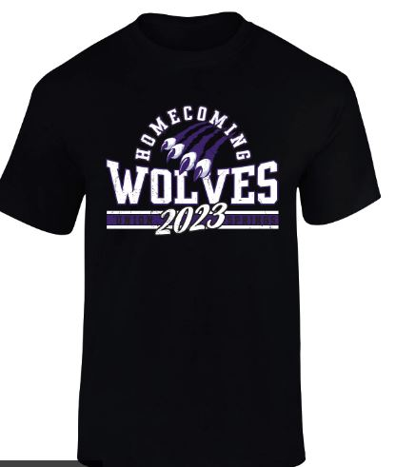
Order today and show your school spirit!
Return bottom of slip to Mrs. Horbal in room 218
Student Name________________________
First period teacher ______________
Contact number________________________

Short sleeve T-Shirt $15 QTY ________
Please circle preference
S M L Xl 2XL(add $2)

Dri Fit T-shirt $17 QTY________
Please circle preference
S M L XL 2XL(add $2)

Please return all money and order forms to Mrs. Horbal
No Later than SEPTEMBER 5TH (The first day of school)
Checks can be made out to Union Springs Class of 2024

